The 4th Regional High-Level Meeting on Migration and Tuberculosis: Cross-Border TB Control and Care in the Central Asian Region
Astana, Kazakhstan, December 5-6, 2018
Тhe 4th High-Level Regional Meeting on “Migration and Tuberculosis (TB): Cross-Border TB Control and Care in the Central Asian Region” convened on December 5 and 6, 2018 in Astana, Kazakhstan. Central Asia government officials, national TB program and migration authority representatives, experts from the World Health Organization (WHO), the STOP TB Partnership, and non-governmental organizations (NGOs) and civil society participated to develop mechanisms for regional coordination of TB diagnostic and treatment efforts among labor migrants. The meeting was organized by the Republic of Kazakhstan Ministry of Health National Scientific Center of Phthisiopulmonology and Project HOPE with financial support from the Global Fund and the United States Agency for International Development (USAID).

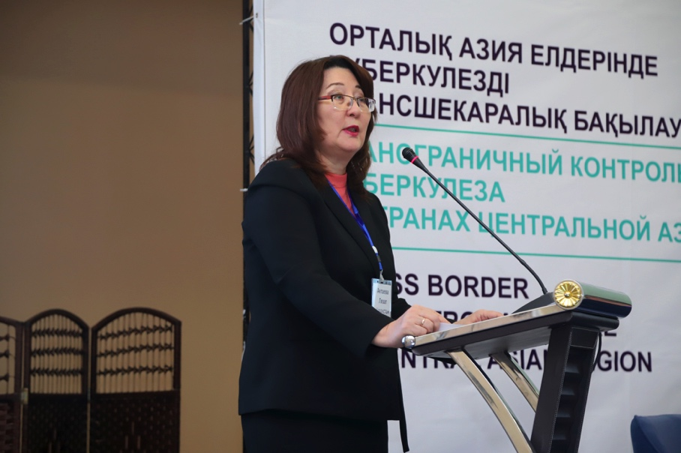 | Lyazat Aktayeva, the Republic of Kazakhstan Deputy Minister of Health, welcomes participants to the 4rd Regional High-Level Meeting on Migration and Tuberculosis hosted by Project HOPE, Kazakhstan Ministry of Health, the Global Fund, and USAID in Astana, Kazakhstan.
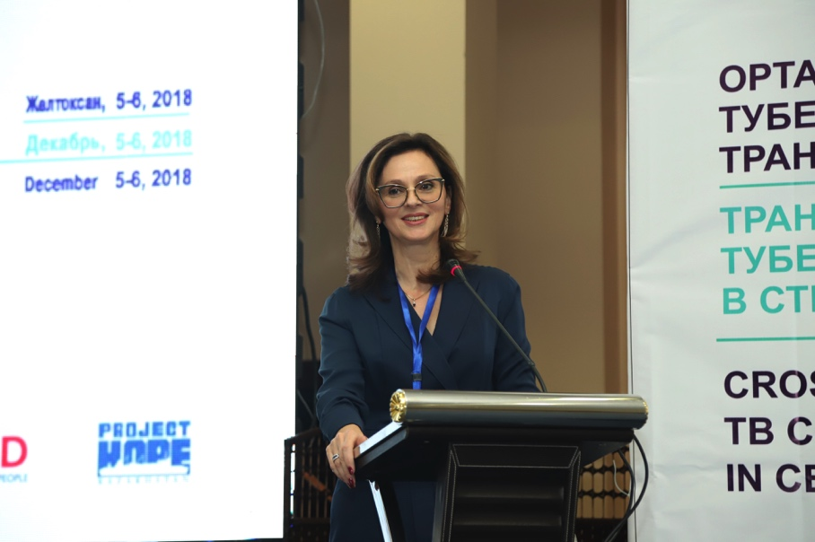 | Mariam Sianozova, Project HOPE Senior Regional Director for Europe and Central Asia: “The high-level meetings on migration and TB serve as an effective platform for Central Asian governments, non-governmental institutions and experts for advancing cross-border TB care and prevention among migrants.”
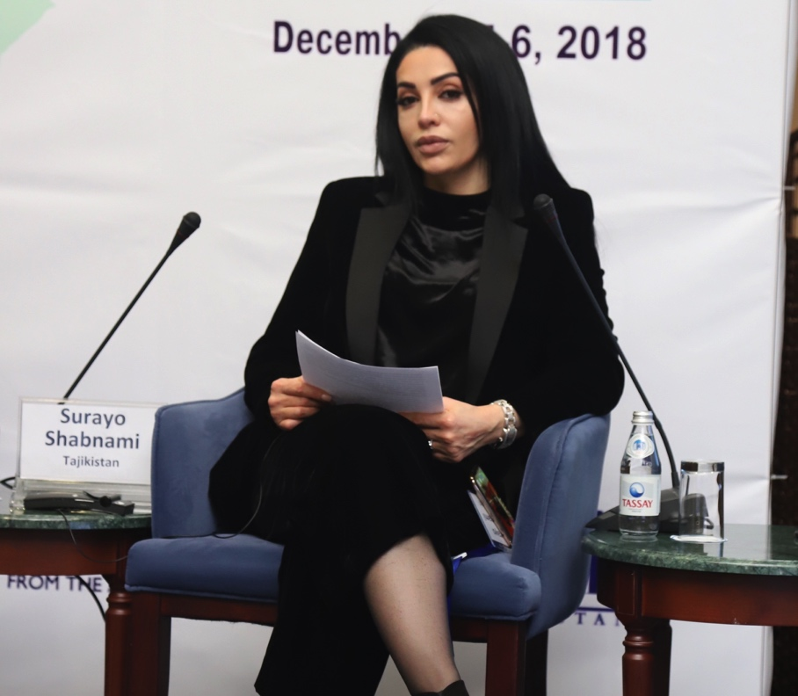 | Shabnabi Surayo, a Tajikistan pop star and a United Nations goodwill ambassador, participated in the 4th High-Level Regional Meeting on Migration and Tuberculosis: “I know many people affected by TB and am committed to fighting this disease.”
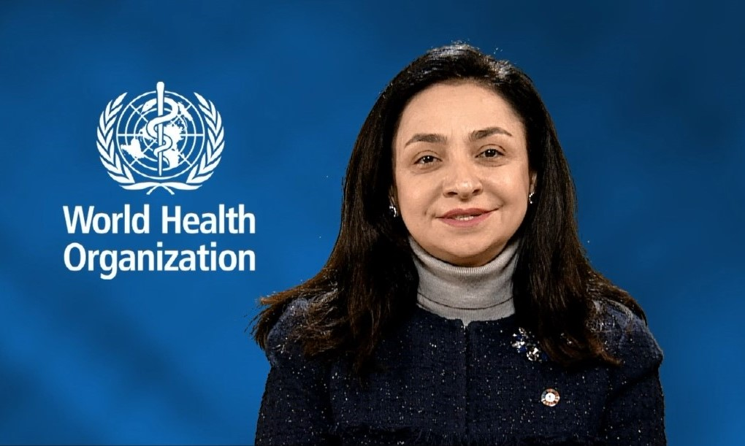 | Tereza Kasaeva, Director of the WHO Global TB Program: “We need to unite forces to accelerate our TB response and ensure that vulnerable groups have access to qualified TB care services and are protected from stigma.”
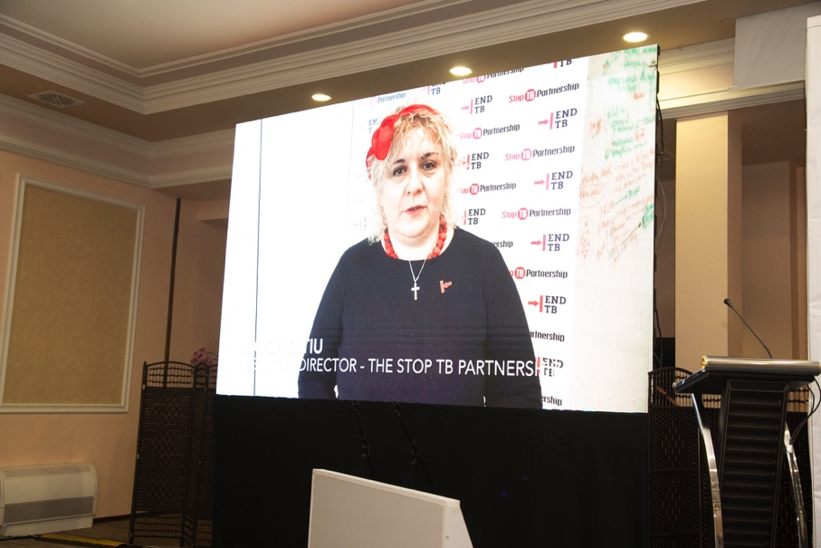 | Lucica Ditiu, Executive Director of the STOP TB Partnership: “This meeting represents a great opportunity to come together and look at what we can do differently so that we can make a big shift towards achieving the goals of the declaration of the United Nations High-Level Meeting on Fight to End TB adopted in September 2018.”
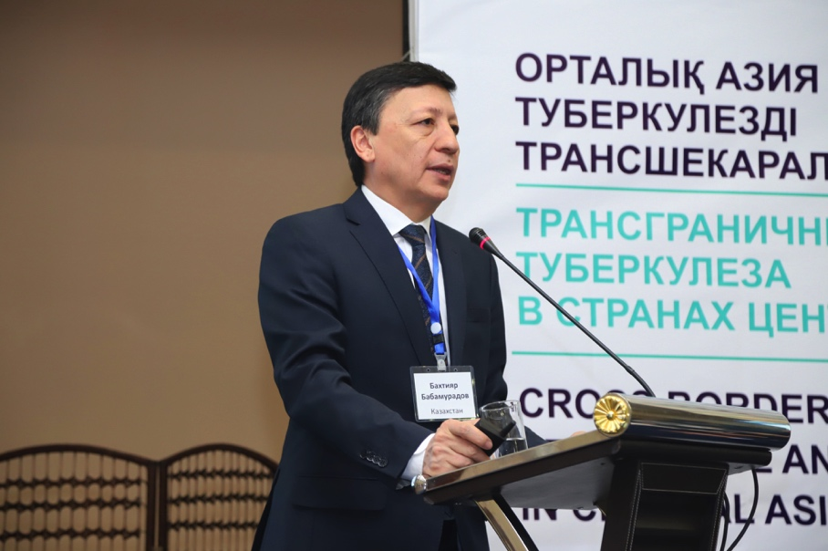 | Bakhtiyar Babamuradov, Project HOPE Kazakhstan Country Representative: “With support from the Global Fund, we are addressing cross-border TB control among labor migrants in Kazakhstan focusing on governance, service delivery, monitoring, and creating a supportive environment.”
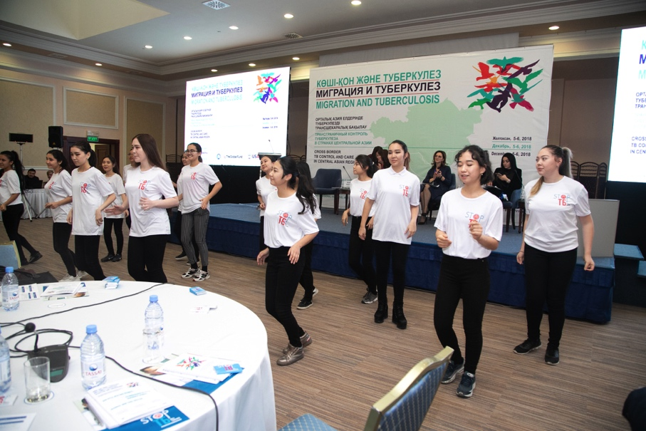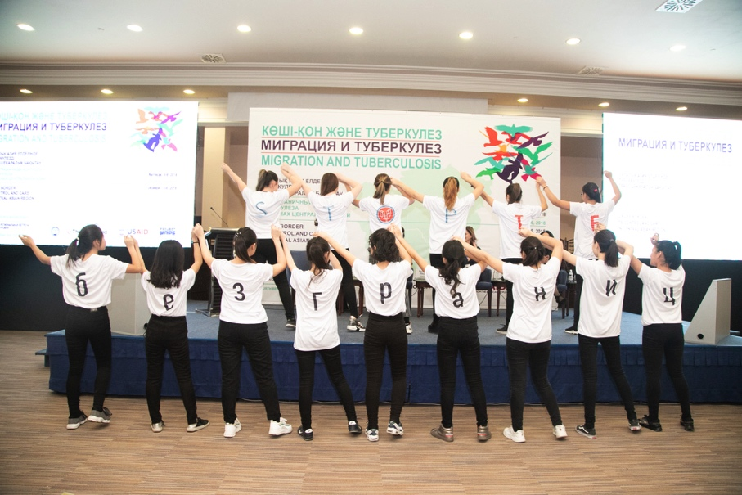 | The 4th High-Level Regional Meeting on “Migration and Tuberculosis (TB): Cross-Border TB Control and Care in the Central Asian Region featured the Stop TB without Borders flash mob with the participation of volunteers from the non-government organization Zhariya International Center, Astana, Kazakhstan. Similar performances to build public awareness and emphasize key TB messages and the need to engage communities in providing support of TB patients and reducing TB-related stigma were held previously in large shopping centers in Kazakhstan and Tajikistan. A video material on these events is available here:  https://drive.google.com/file/d/1nsGVUshvkMMYEjJSjbEEPB59TGFjmRPR/view?ts=5c0d694a
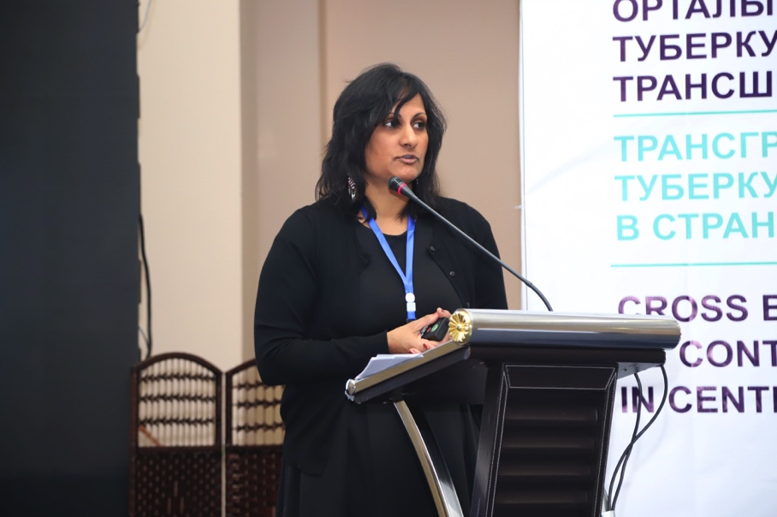 | Rajita Bhavaraju, Deputy Director of Global Tuberculosis Institute, Rutgers University: “Stigma should be acknowledged among patients, families, health care personnel, and communities. Stigma reduction is the responsibility health care personnel, facility administrators, the media, and the government.”
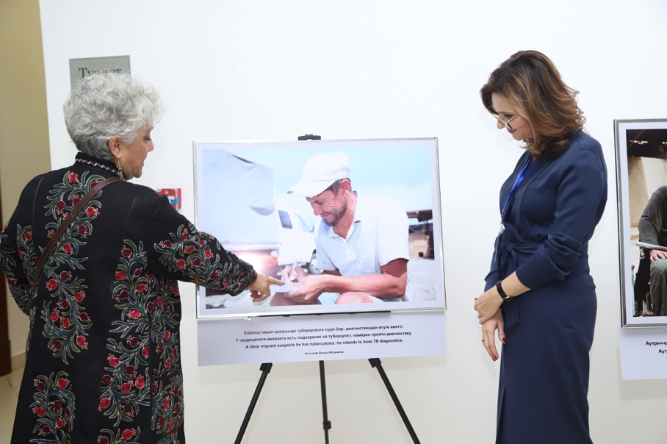 | The 4th High-Level Regional Meeting on “Migration and Tuberculosis (TB): Cross-Border TB Control and Care in the Central Asian Region features the Come Back Home Healthy! Photo Exhibition to bring into public focus TB among vulnerable population groups. Organized by Project HOPE with support from the Global Fund and USAID, the exhibit also toured in the Kyrgyz Republic and Tajikistan.
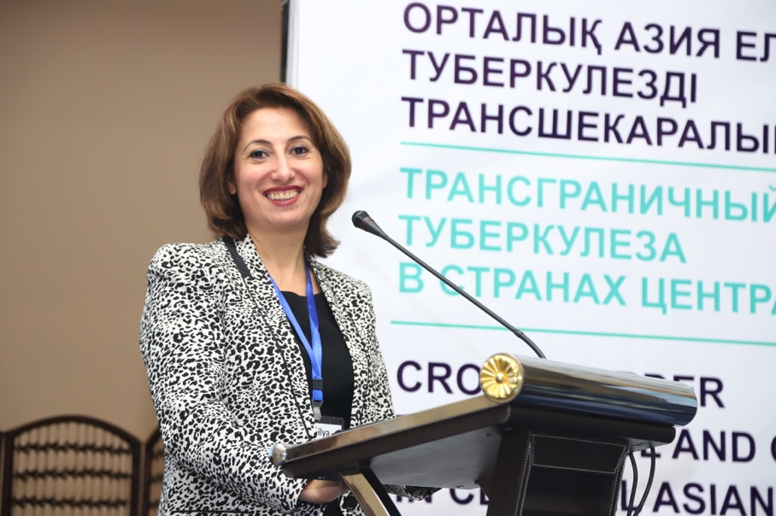 | Jamilya Ismolova, Project HOPE Regional Community Engagement Advisor/Country Representative for Tajikistan, at High Level Meeting on TB and Migration: “If we want to end TB, we need to work hand-in-hand with civil society. A lot has been accomplished, including building of national civil society networks to fight TB in communities. The next step is the establishment of the Central Asian regional network.”
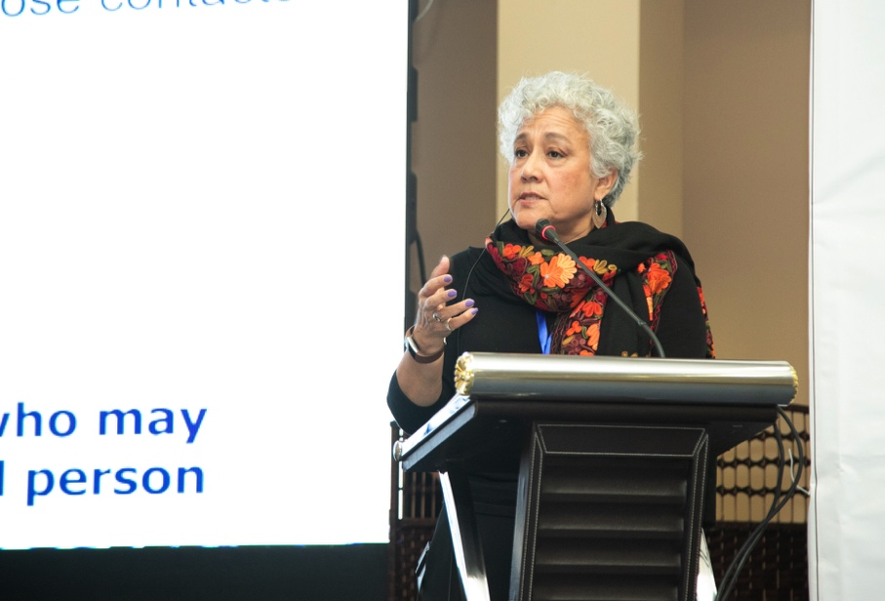 | Deliana Garcia, Director of International Projects, Migrant Clinicians Network, USA: “Contact tracing stops the spread of many different infections in the community by finding and informing the people that an infected person has been in contact with so they can get counseling, testing, and treatment.”

The selected and additional photos are available here:
https://drive.google.com/drive/folders/14v6X--6qv8LMkaUb7Vi-FO3mEilYb84-?usp=sharing

